**Cryptography and Network Security Lab (6CS451)**

**Assignment No 4**

**Name : viraj Patil**

**PRN : 21510097**

1. Implementation of Chinese Remainder Theorem (CRT)

**Code :**

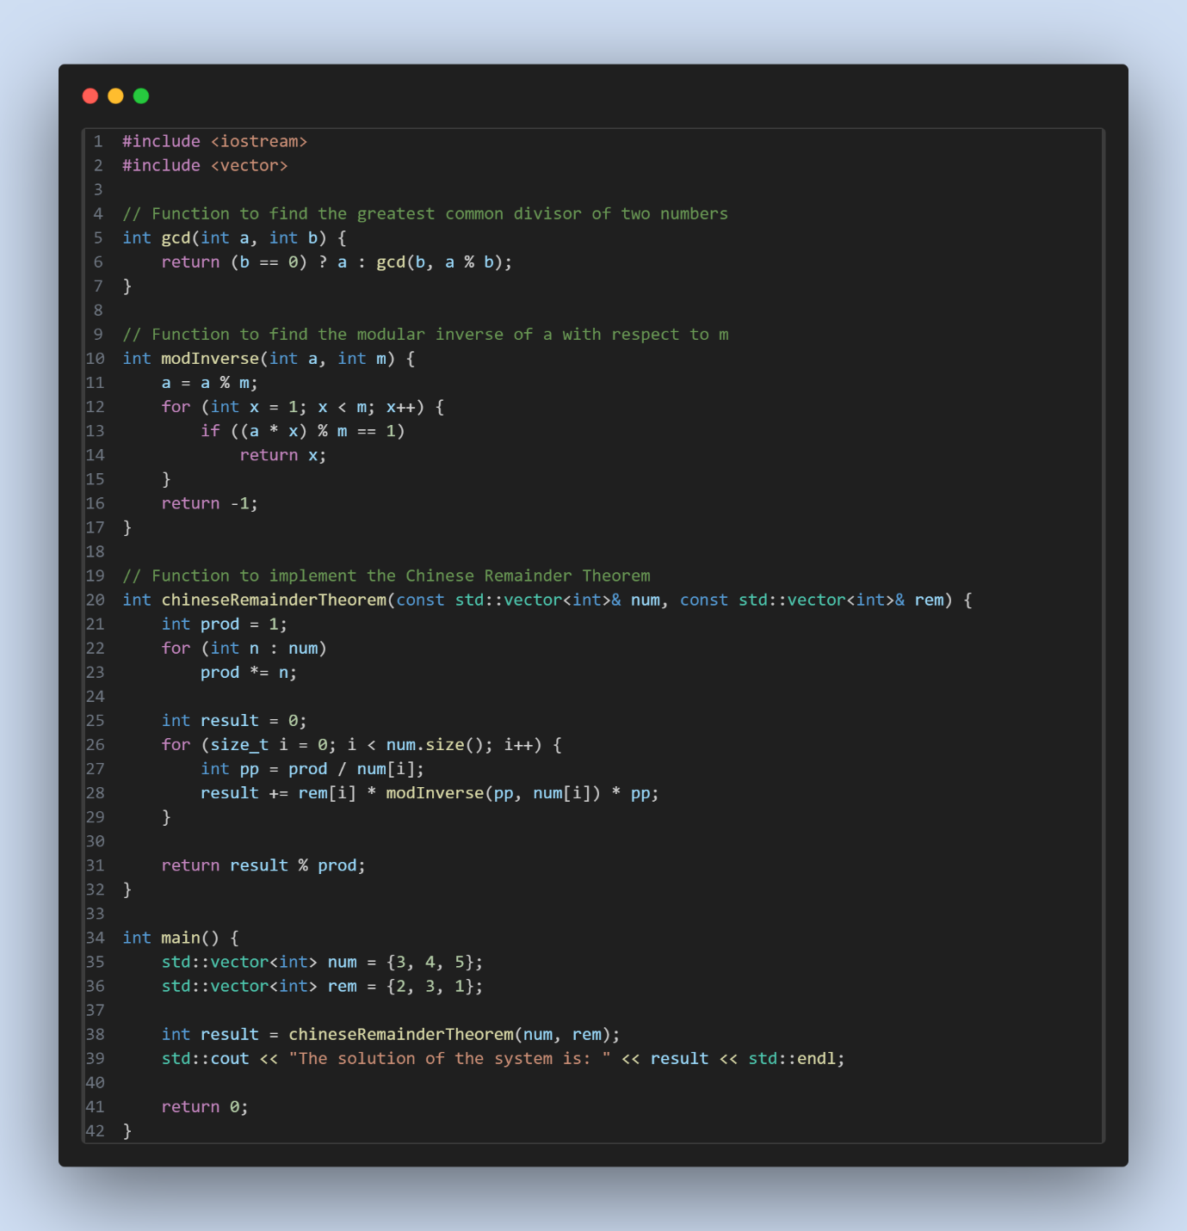

**Output :**

